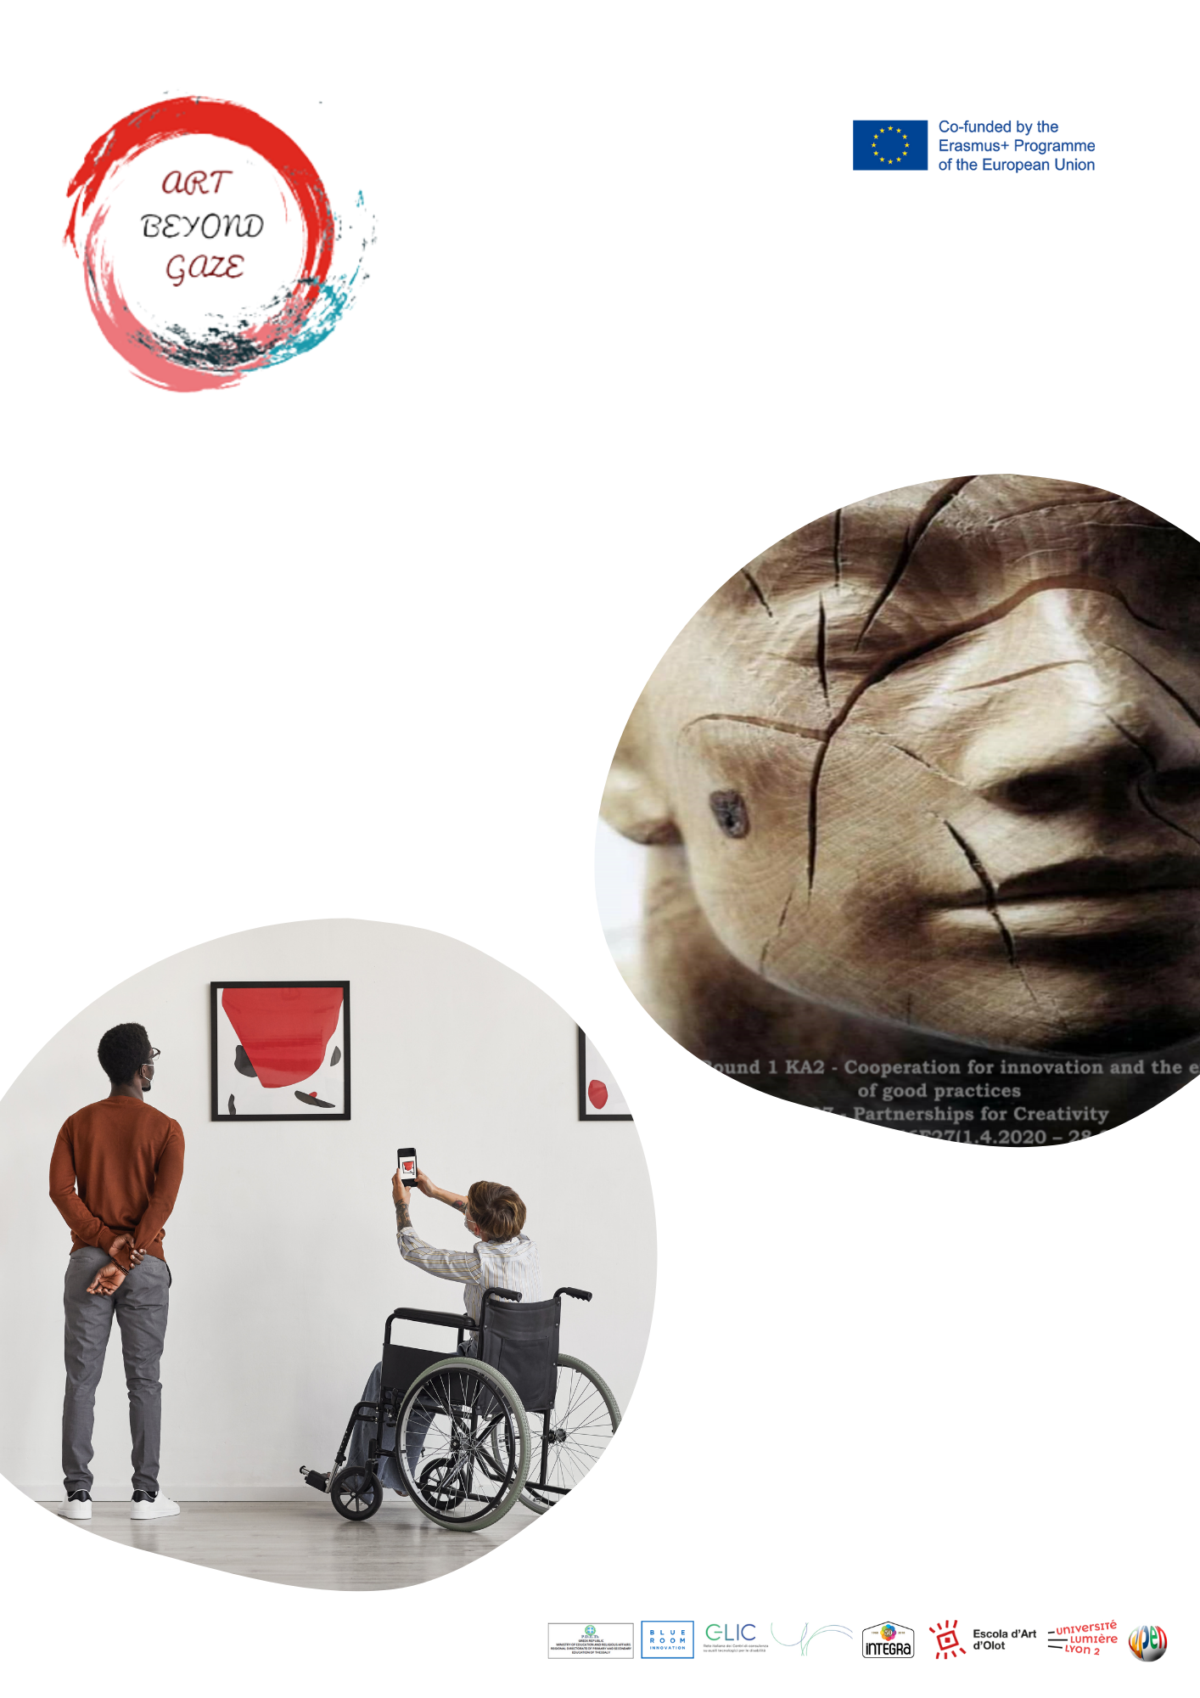
1st Local Workshop Implementation Report

Date Here
COUNTRY | PARTNERS
GREECE | PDETh  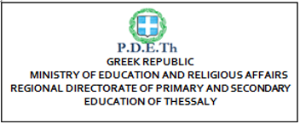  OPEN UP

- Introduction
The first local digital workshop took place in Larissa on 7-8-9/12/21 in the computer room of the Music school and involved 16 students of the music school, 3 adult students of the Vocational High School and 3 students of the school with special needs of Larissa.
Teachers which have participated are: Eleni Kalampaliki from the 4th Vocational School of Larissa, Stauroula Prantsoudi from the Music School of Larissa, Vasiliki Vasilopulou, Vasiliki Tsimitseli and Evagelia Balafa from the Special Educational School of Larissa
Responsible from PDETh are: Ioanna Chatzopoulou and Zissis Zikos
Responsible from Open up are: Stelios Orfanakis, Aikaterini Ganatsiou and Giwrgos Giannakas

- Choice of Thematic in Digital Art’ Training

The thematic of these Local Workshops was the recreation of a painting using a digital tool with which the students were very familiar, as all of them have used it before and implemented it within the related courses of Technology Information in school’s curriculum. As the subject of the 3-day Local Workshops was “Training in digital creativity with application in Education and Art; Rebuilding the cubism through Scratch”, we chose a painting well-known for its symbolism and cubism in this content, the famous “Guernica” of Picasso. So, we rebuilt

creatively this painting, using Scratch and most of all investing and developing the imagination and creativity of our students.

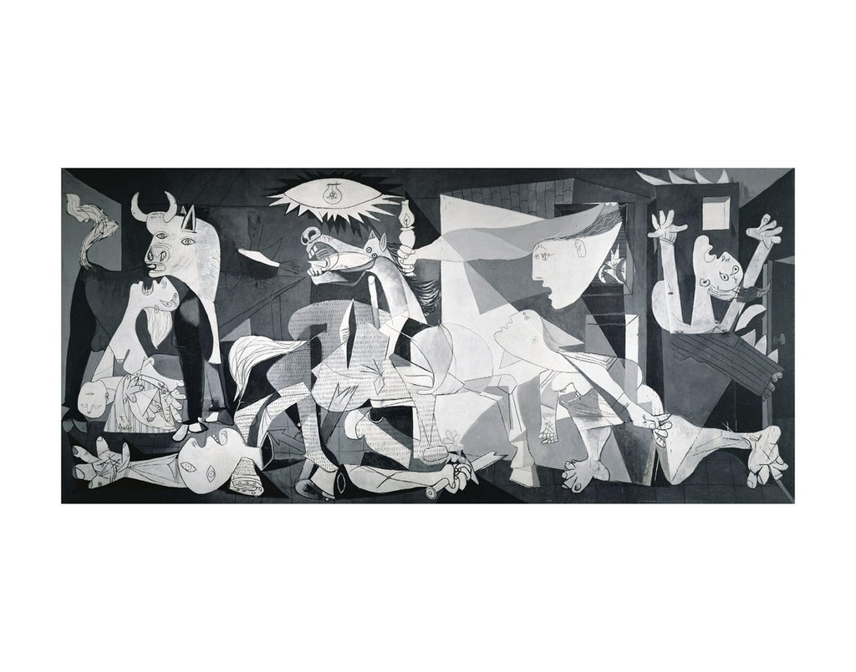
The Guernica of Picasso

- Choice of Digital Material

Digital Material: The digital Scratch program, with 3d pictures and sound.
The artist Eleni Kalampaliki isolated essential elements of the painting that are symbolic parts of the Guernica, such as the bull, the mother with the dead child in her arms, the candle, the eye, the lamp, and all these issues were the moving material (which was properly shaped by the technicians of Open Up organization). The students were asked to transform all these parts of the painting, to color them and to combine them with each other in order to create something new and fresh. Also, graffities from the city’s walls that the artist has photographed and the technicians of the Open Up have edited for the students' creations, was used as a background.

- Agenda of the Local Workshop

Session | Activity Carried Out
- 7/12/21  9.30-11.00: Questionnaires of expectation  Introduction in the project ABeyGa, information on Scratch  11.20-13.00: Practice on Scratch  Composition of different backgrounds to recreate the Guernica  - 8/12/21  9.30-11.00: Presentation of Guernica –Cubism and discussion on its symbols.  11.20-13.00:  Combination of the different the moving materials (eg the bull, the eye) with the background, choosing the color, making the issues move.  - 9/12/21  9.30-11.00: Synthesis of digital paintings with scratch  11.20-13.00: Video-music production –Conclusion of the workshop. Evaluation (Questionnaires of satisfaction). | Face – face  Face-face  Face-face

- Description of 3 Day Activities

On the first day, the students and their teachers had the opportunity to get to know the school infrastructures where the workshop was held and take a tour in the classrooms with the different music tools. They were thus given time to get to know each other so that they could form a team capable to work together. The dialectic relationship that developed between the older students and the students of the special school was particularly special. The Regional Director of Education of Thessaly, Ms. Ziaka V. addressed a greeting to students and teachers welcoming actions that promote education and culture. Also, the students were given the necessary information about the Art Beyond Gaze program and its objectives. Finally, the students were informed about the aims of the Scratch digital project and made practice on this subject utilizing the 10 photos of wall-graffities of Larissa (where they live), so that the students use them as a background in their work.

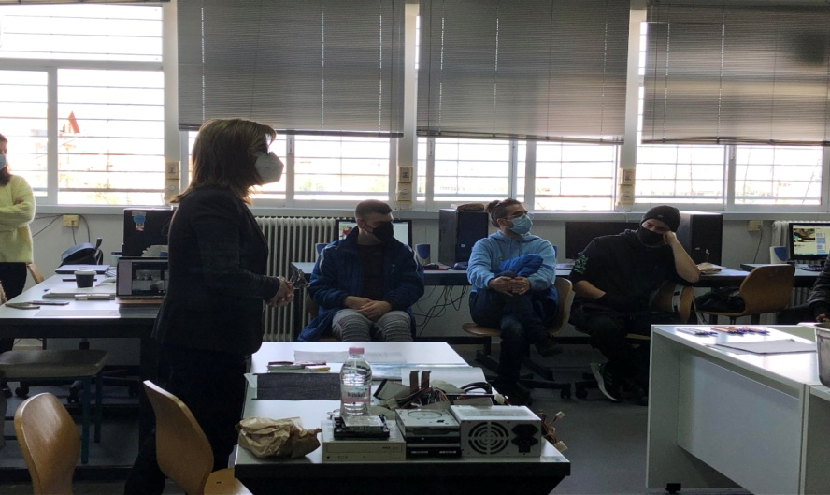
Ms Vasiliki Ziaka addresses to the students of the three schools

On the second day of the workshops the students had the opportunity to practice more on the digital scratch program, after the presentation of the documentation on Guernica and the related discussion on its symbolism. The students were asked to use the isolated essential elements of the painting -the most symbolic parts of the Guernica- such as the bull, the mother with the dead child in her arms, the candle, the eye, the lamp, which became moving material in the context of Scratch. The students were, also, asked to transform all these parts of the painting,

to color them and to combine them with each other in order to create their own personal “Guernica”. The main theme of their work was to incorporate Picasso's drawings from the painting Guernica into them, using rules of composition and balance in drawing and colour.
At this point the students worked together in pairs or groups of two or three, so that they exchange ideas, techniques and digital skills.

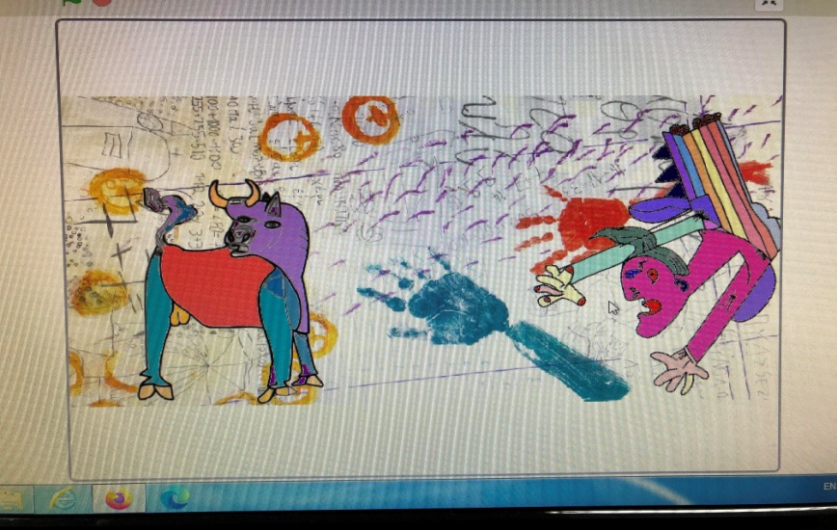
Creation of the students with the moving material of Guernica colored

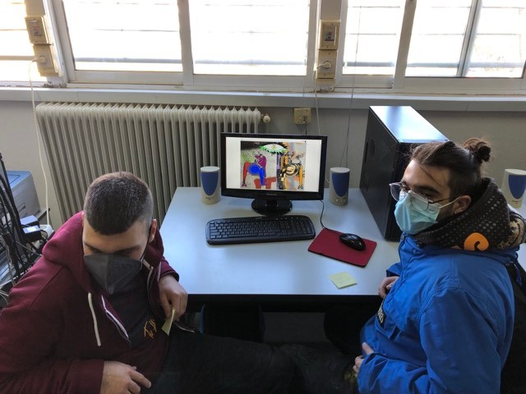
Pair of students (one of 4th Vocational School of Larissa and one from Special Educational School of Larissa)

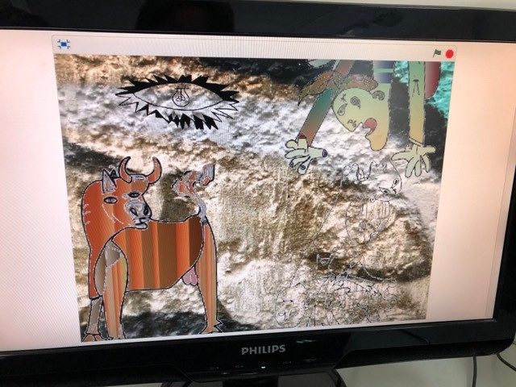
Combination of the background with the bull -colored in red- of Guernica

On the last day, the students completed and presented the results of their work.
Additionally, they created a video -made by themselves- invested with music.
Finally, they were all invited to share experiences of their participation in this project.

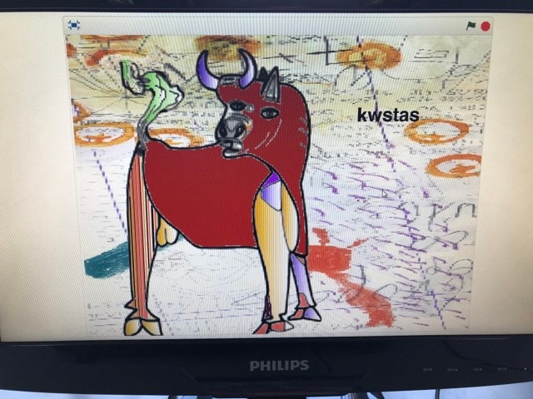

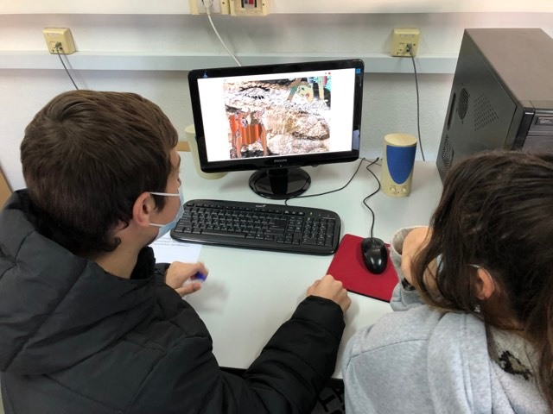
Pair of students of the Music School of Larissa working on their creation

- Outcomes & Evaluation of the Teaching

The results of the digital workshops were evident from the very first moment, when students of different schools of Larissa meet each other. They developed friendly relationships and collaborated in a context of mutual estimation and acceptance of diversity by supporting and complementing each other's thinking and creations. They underlined that they were very interested in approaching art through digital material and especially through scratch and expressed their enthusiasm to work with this famous Picasso paining, the “Guernica”. The use of different backgrounds helped them to discover the graffities -which are beautiful and alternative art creations- of their city. The evaluation of the participants expressed through the completed questionnaires of expectations (in the beginning) and of satisfaction (in the end of the local workshops).

- Conclusions

The combination of the digitalization (through the scratch program) with the art can yield very remarkable results regarding students aged 15-23, when it is supported by the right guidance and it is implemented in the context of the mutual understanding and harmonic cooperation. The collaboration between different Schools (Music School – Vocational School – Special Educational School) was very interesting due to the fact that students of different ages and with

different skills and abilities work together to build this bridge of self-expression, communication and integration.

