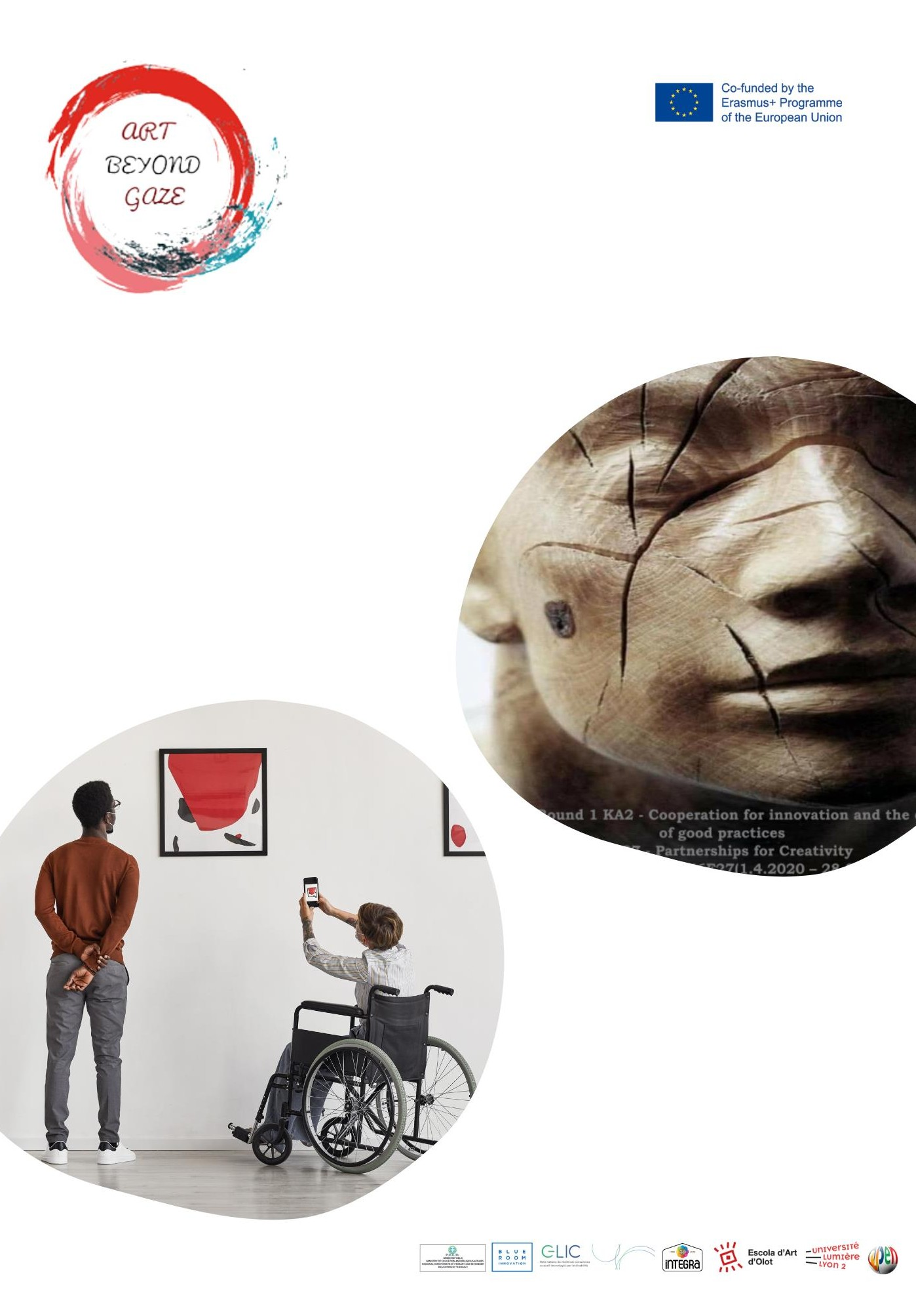

2nd Local Workshop Implementation Report

May 2022

COUNTRY | PARTNERS
GREECE | PDETh  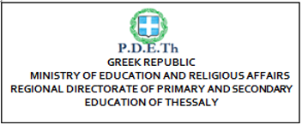  OPEN UP

- Introduction
The second “Art Local Workshops” in plastic art through art therapy learned in Olot, Spain, of Greece took place in Larissa on the 10th, 11th and 12^{ve} of May in the Graphic Arts Laboratory of the Applied Arts Department of the 2nd EK and of the 4th Vocational High School of Larissa and involved 20 students in total from the Vocational School and 4 students of the School with Special Needs of Larissa.
Teachers which have participated are: Eleni Kalampaliki from the 4th Vocational School of Larissa, Agapi Charakopoulou, Elena Ageli, Marianna Yannakou and Persefoni Panaga from the Special Educational School of Larissa
Responsible from PDETh are: Ioanna Chatzopoulou and Zissis Zikos
Responsible from Open up are: Stelios Orfanakis, Aikaterini Ganatsiou and Giwrgos Giannakas

- Choice of Thematic in Plastic Art’ Training

The thematic of these 3-day Local Workshops entitled "Before and After: Objects Tell Their Own Story. A journey through time with the suitcases of Alexis Akrithakis" is connected with a famous

Greek artist (Alexis Akrithakis). On the occasion of the video "Chromatohistories - Akrithakis" the artist teacher Eleni Klambaliki discussed with the students about the work of Alexis Akrithakis. The students observed the intense colors and symbols in his paintings as well as his special artistic writing
and wondered what the suitcase symbolizes in his work, while the most of the students agreed on “the journey, the adventure!”. With these images in mind the students designed their own suitcase with the
objects of their every day. The aim of these Local Workshops was the art creation based on materials of everyday life in order for the students to wide their point of view so that they see the magic of art in the hole of their life. The participating students approached various objects of everyday use, using materials such as clay and plaster, to reconstruct these objects and create their own "Suitcases" according to the example of Alexis Akrithakis. So, we reconstructed creatively our suitcases investing and developing the imagination and creativity of our students.

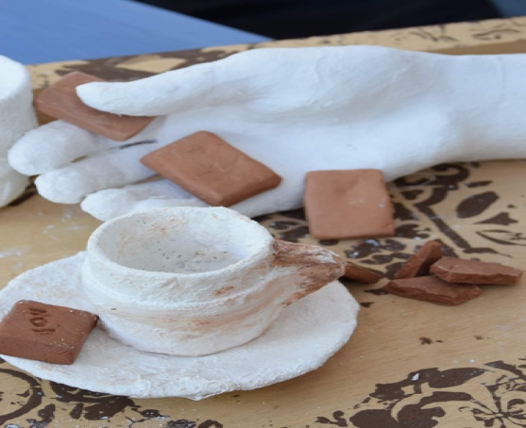
Reconstructing Materials of Everyday Life
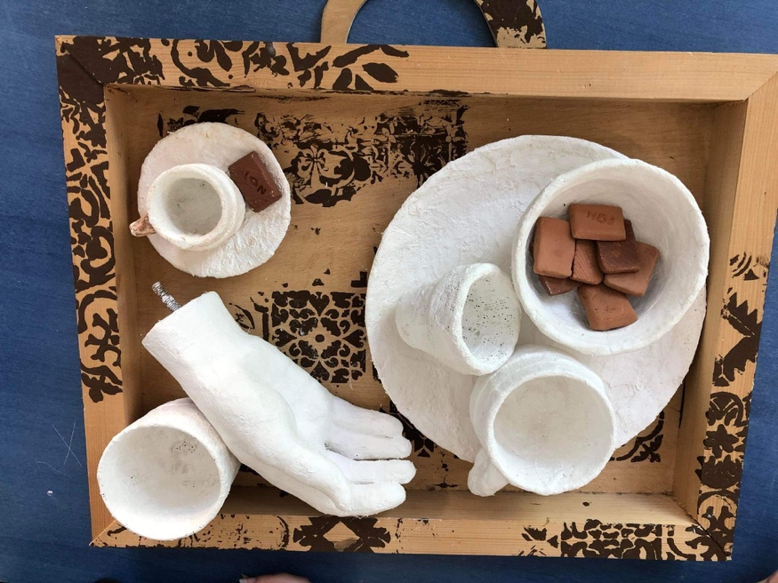
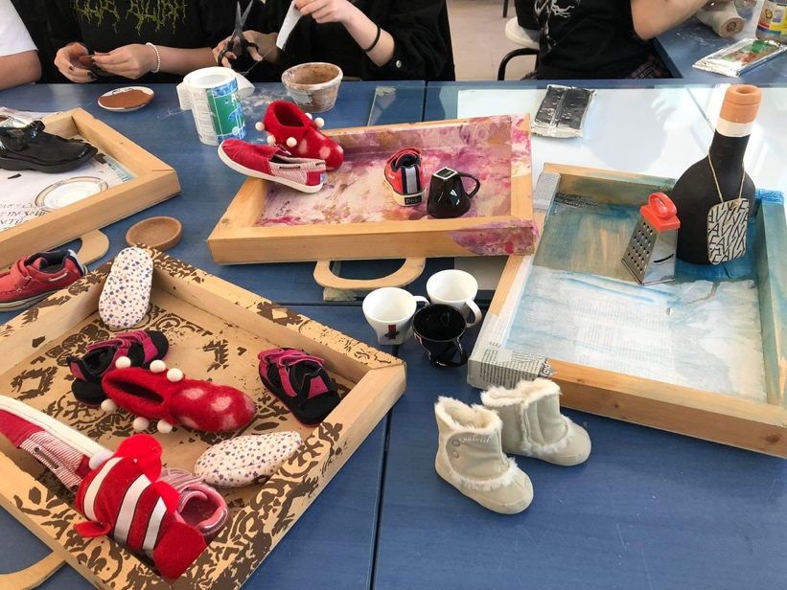 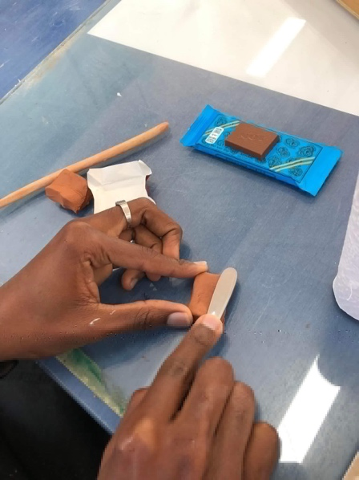 When shoes, cups, bottles and chocolate become artistic materials in the students hands to create their suitcases, according to the examole of Alexis Akrithakis

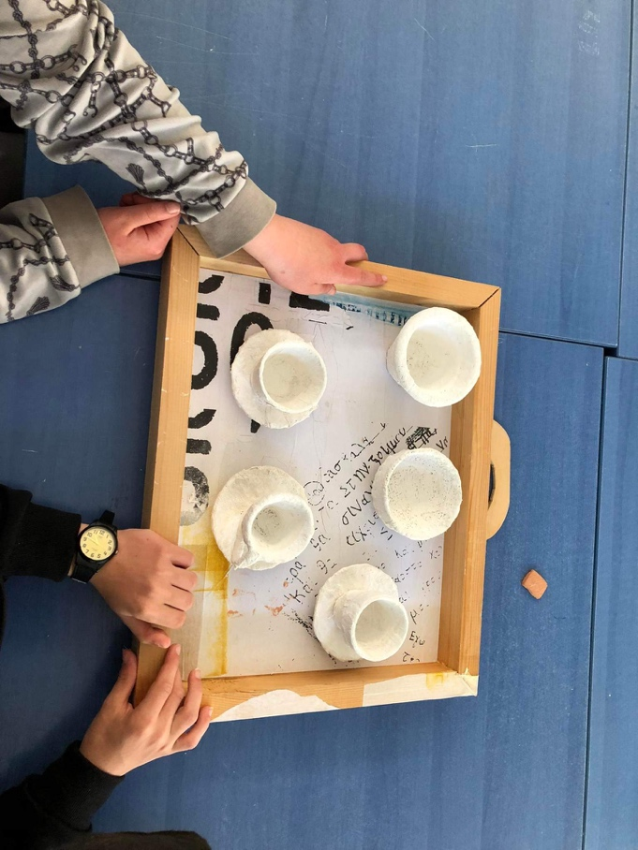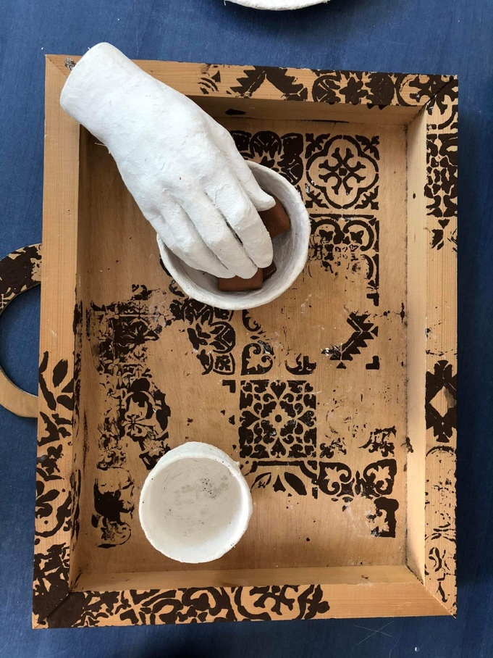

3. Choice of Plastic art material

Why clay? The answer for using clay (also true of oil-based clays) is that we can move it to how, what, and where we want it. Within limits, it does what we want it to and can take on any form, surface, or texture that we can think of. We do not believe that we should always bend to the 'will' of the material being used. Neither do we believe that it the nature of the material should be ignored. It is always a dialogue, like art itself, and material use is part of that conversation.
Using clay and plaster the students reformed creatively a cup, a piece of chocolate.
Tweaking and changing is part of the art creation , while students should be encouraged to interact with sculpture, and this can be something extremely important for the visually impaired. Painting is exclusive as an art form. Being flat and (largely) wall mounted, interaction is purely visible. One of the strengths of sculpture is that it can be interactive and tactile. Taking into consideration the basic aim of this project to make art a bridge between students with and without SEND, the choice of clay and plaster supported efffectively this interaction between the students and the art material and between the teams of the students, giving occasions for collaborations and collective artistic creation.

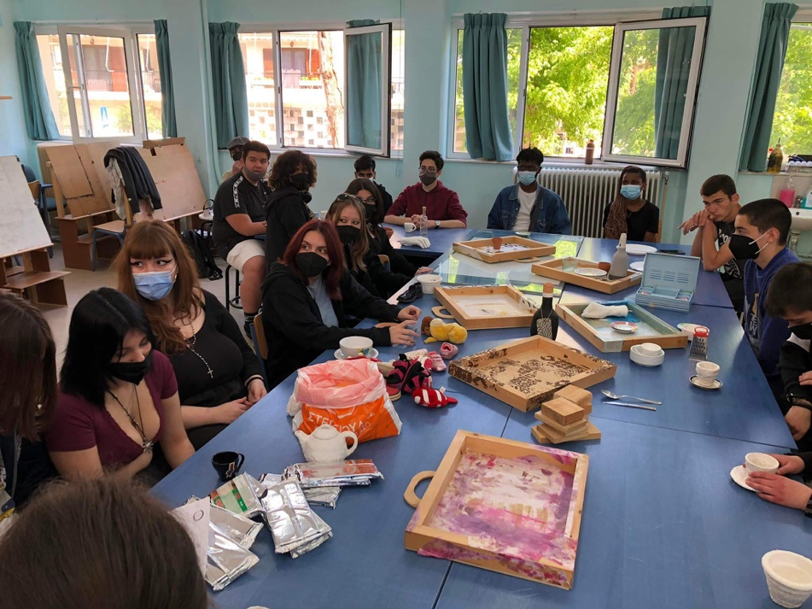

Working with the clay
Collaborating with each other

4. Agenda of the Local Workshop

DAY 1
TUESDAY, MAY 10, 2022
10.00 - 13.00
10.00-10.20 Reception of students
10.20 - 10.40 Presentation of the participants (introduction to the students, work experience of the trainers, link to the programme)
10.40 - 11.00 Theoretical approach to ABeyGa program.
11.00 - 11.15 Break.
11.15 - 12.15 Introduction to the materials - making objects with plaster and clay.
12.45 - 13.00 Discussion, conclusions, questions.
DAY 2
WEDNESDAY, 11 MAY 2022
10.00 - 13.00
10.00 - 11.00 Visual approach to objects of everyday use through the presentation of photos of the Folklore - Historical Museum of Larissa
11.00 - 11.15 Break.
11.15 - 12.15 Continuation of the practical process-Composition of works.
12.45 - 13.00 Discussion, conclusions, questions.
DAY 3
THURSDAY, 12 MAY 2022
10.00 - 13.00
10.00 - 11.00 "Before and After" Our objects tell their own story, A journey through time with the suitcases of Alexis Akrithakis.
Synthesis of works.
Completion of personal creation
Final creation by all students.
Downloading of video with the works of the student-creators.
11.00 - 11.15 Break - Transfer to the Folklore - Historical Museum of Larissa
11.15 - 12.45 Guided tour of the Folklore - Historical Museum of Larissa and completion of the museological study
12.45 - 13.00 Discussion, conclusions, questions.

5. Description of 3 Day Activities

During implementation, 3 sessions took place:

On the first day, the students and their teachers had the opportunity to get to know the school infrastructures where the workshop was held and take a tour in the classrooms with the different Laboratories. They were thus given time to get to know each other so that they could form a team capable to work together. The dialectic relationship that developed between the older students and the students of the special school was particularly special. The Regional Director of Education of Thessaly, Ms. Ziaka V, underlined the joy of participation in artistic creation which promote education and culture. Also, the students were given the necessary information about the Art Beyond Gaze program and its objectives. Finally, the students were informed about the famous Greek artist Alexis Akrithakis and his work watching the video titled "Chromatohistories - Akrithakis", while the discussion with the artist teacher Eleni Kalambaliki enlightened the relationships between the intense colors and the symbols in his paintings encouraging the students to answer “what the suitcase symbolizes in his work”. The result of this discussion was that the suitcase symbolizes the journey or an adventure, and that inside we put things of everyday life, memories, experiences of their infancy. The participating students approached various objects of everyday use, such as shoes, cups, plats, bottles etc and worked the clay and plaster, so that they familiarized with these materials. Then, they choose -from a big variety of different objects of everyday life put on the table of the Laboratory- the one they wanted to recreate, recontract and transform.

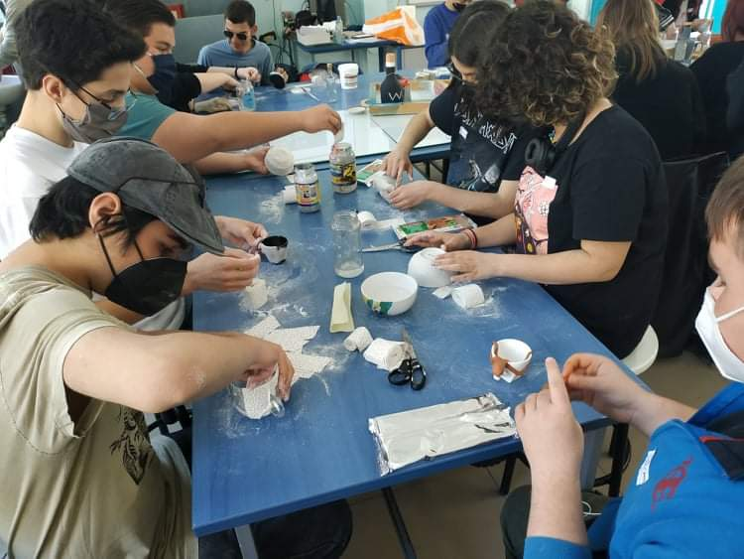
Working with the clay, transforming objects of everyday life

On the second day of the workshops the students had the opportunity to practice more on their work with the clay and plaster and watched a ppt presentation of some things of everyday life exhibited in the Folklore – Historic Museum of Larissa, to think and discuss on the diachronic use of them or to understand their transformation during the years and according to local necessities of the human beings. The students were asked to use the clay in a creative way so that they transform the chosen item. The students were, also, asked to color them and to collaborate each other so that they combine them with each other in order to create their own personal suitcase with their memories and loved art things. At this point the students worked together in pairs or groups of two or three, so that they exchange ideas, techniques and skills.

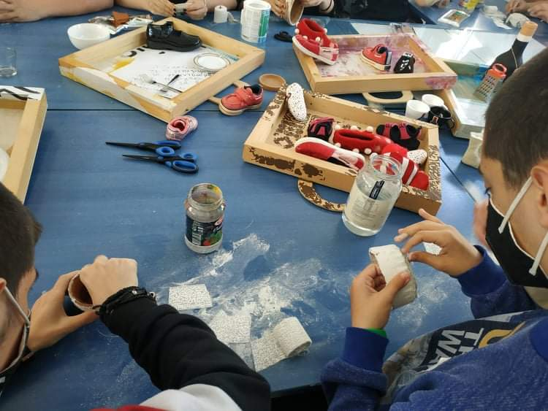

Collaborating with each other, the art as a bridge of communication

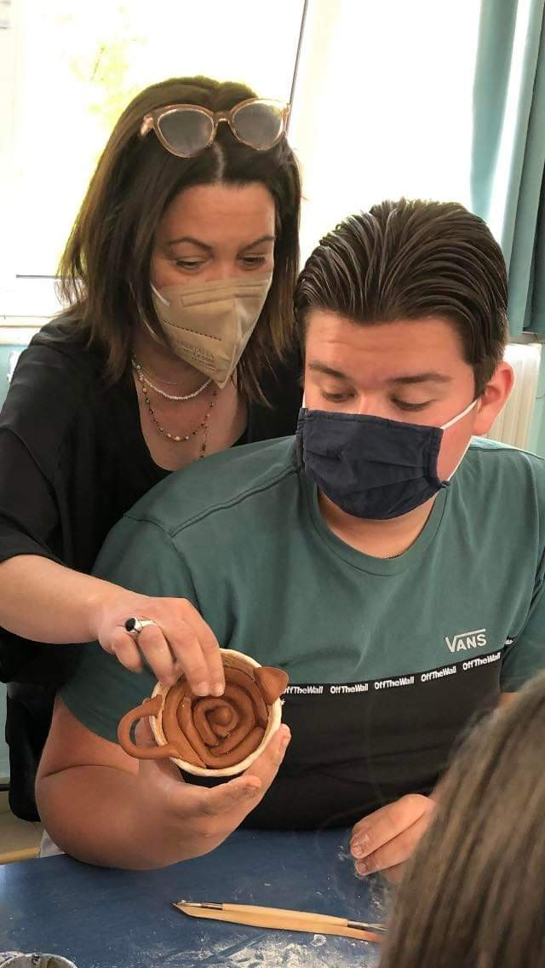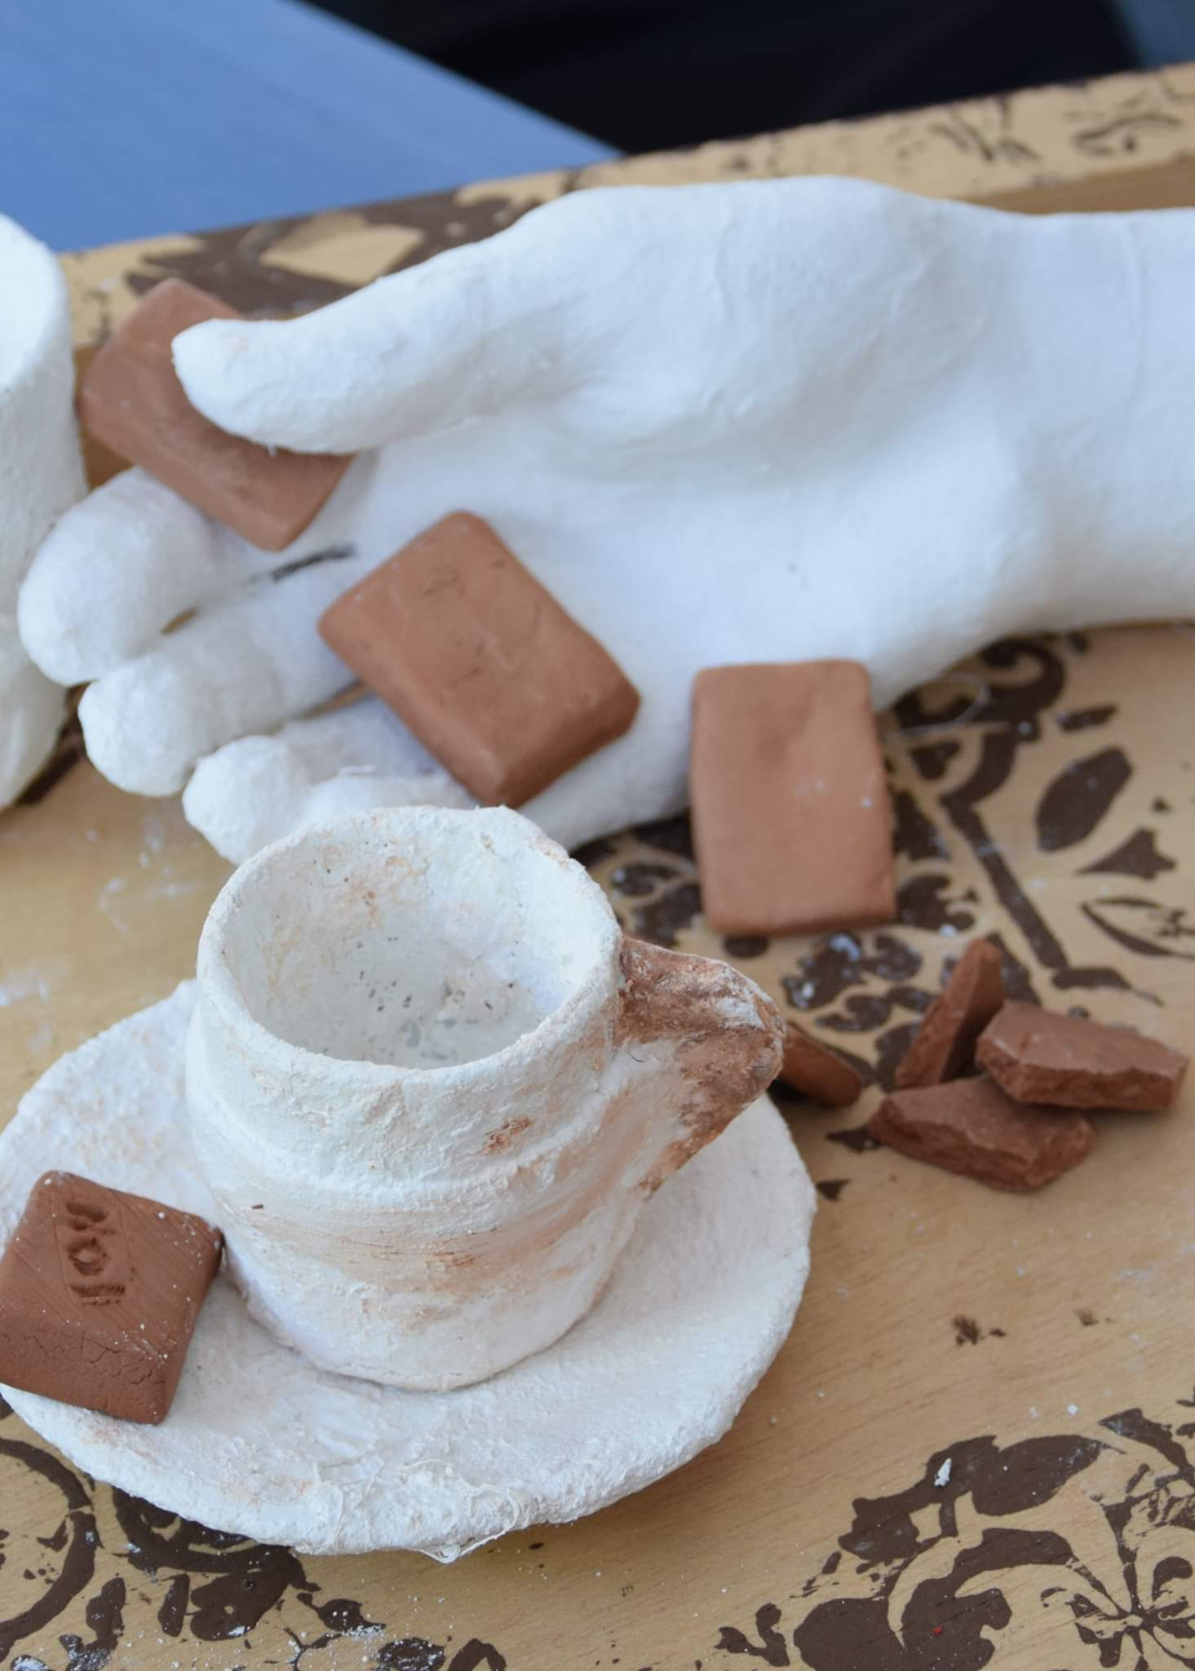

On the last day, the students completed and presented the results of their work. The Local Workshops were completed with an inspiring tour of the students at the Larissa Folklore Historical Museum, delving into the artistic dimension of everyday objects that accompanied the people of our country over time.

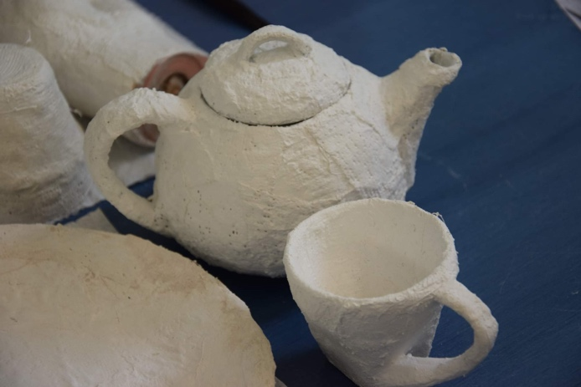Presentation of the students work

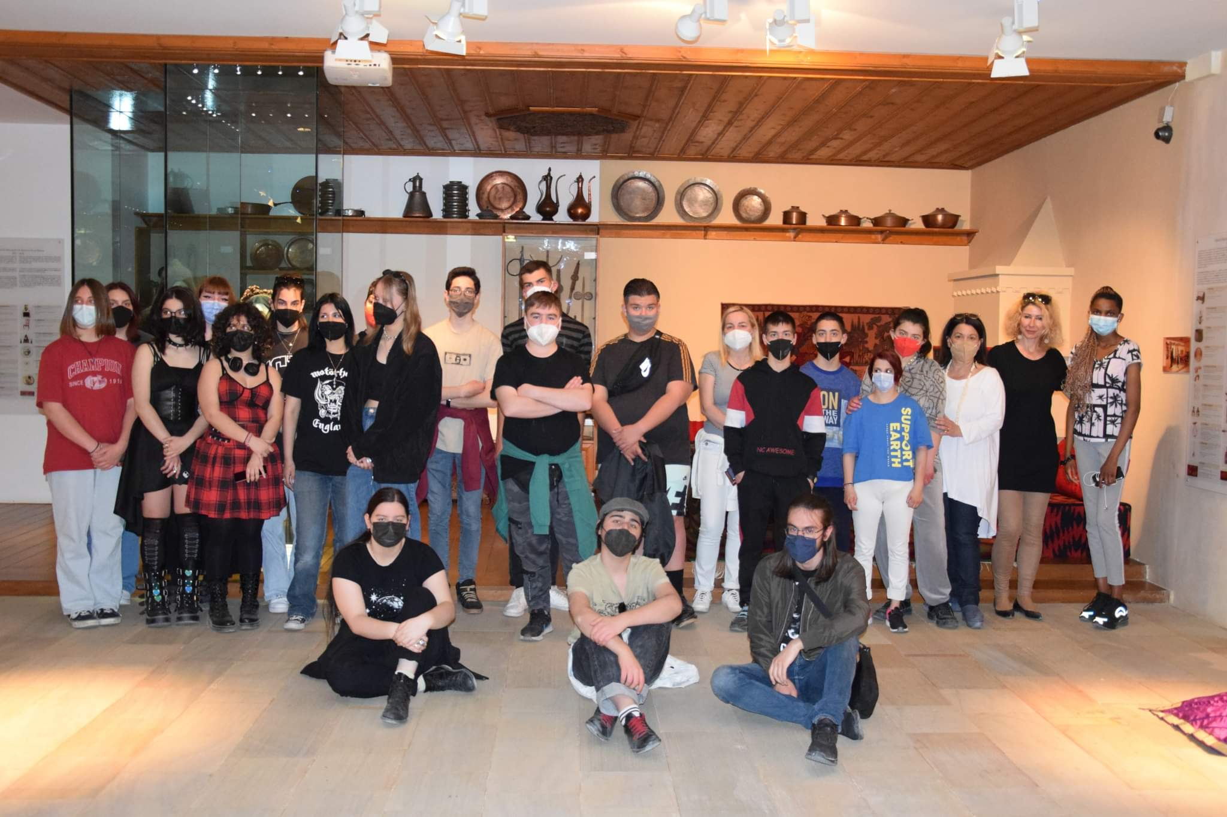

Visiting the Folklore – Historic Museum of Larissa

Outcomes & Conclusion

The results of the Art workshops were evident from the very first moment, regarding the collaboration between students of different schools of Larissa, with different ages, abilities, ethnicities and levels of knowledge. They developed friendly relationships and worked as a team in a context of mutual estimation and acceptance of diversity by supporting and complementing each other's thinking and creations. As in the Art Local Workshops participated also students of different ethnicities and schools, such as refugee students attending the 4th EPAL as well as students from the Single Special Vocational Gymnasium and Lyceum of Larissa, the collaboration between them stressed the value of art as a personal and collective creation, as a dialogue with the different cultures and as a means of developing the cooperation and the teamwork.
The students underlined that they were very interested in approaching art using plastic material and especially clay and expressed their enthusiasm to connect their work with the artistic adventure of a famous Greek artist, Alexis Akrithakis. Additionally, their visit in the exhibition at the Folklore – Historical Museum strengthened their ties with the local and national heritage as they are obliged to deal with the inevitable changes to the national story and the very real, material legacies.

7. Evaluation of the Teaching
The evaluation of the participants expressed through the completed questionnaires showed that the most of them (16/20) expect from this Local Art Workshop to expand their knowledge, to work harmoniously with others and to express their inner self.
Also, they associate to the Local Art Workshops mostly the Sculpture and Painting, as well as the Self-expression / Self-evaluation, the cooperation and the creativity. Finally, they were satisfied by the relevance of the Art Workshops content while they considered them easy to understand.
They found very interesting and playable their experience with the clay and they considered fundamental the acceptance of the opinion and creation of the other human being.

