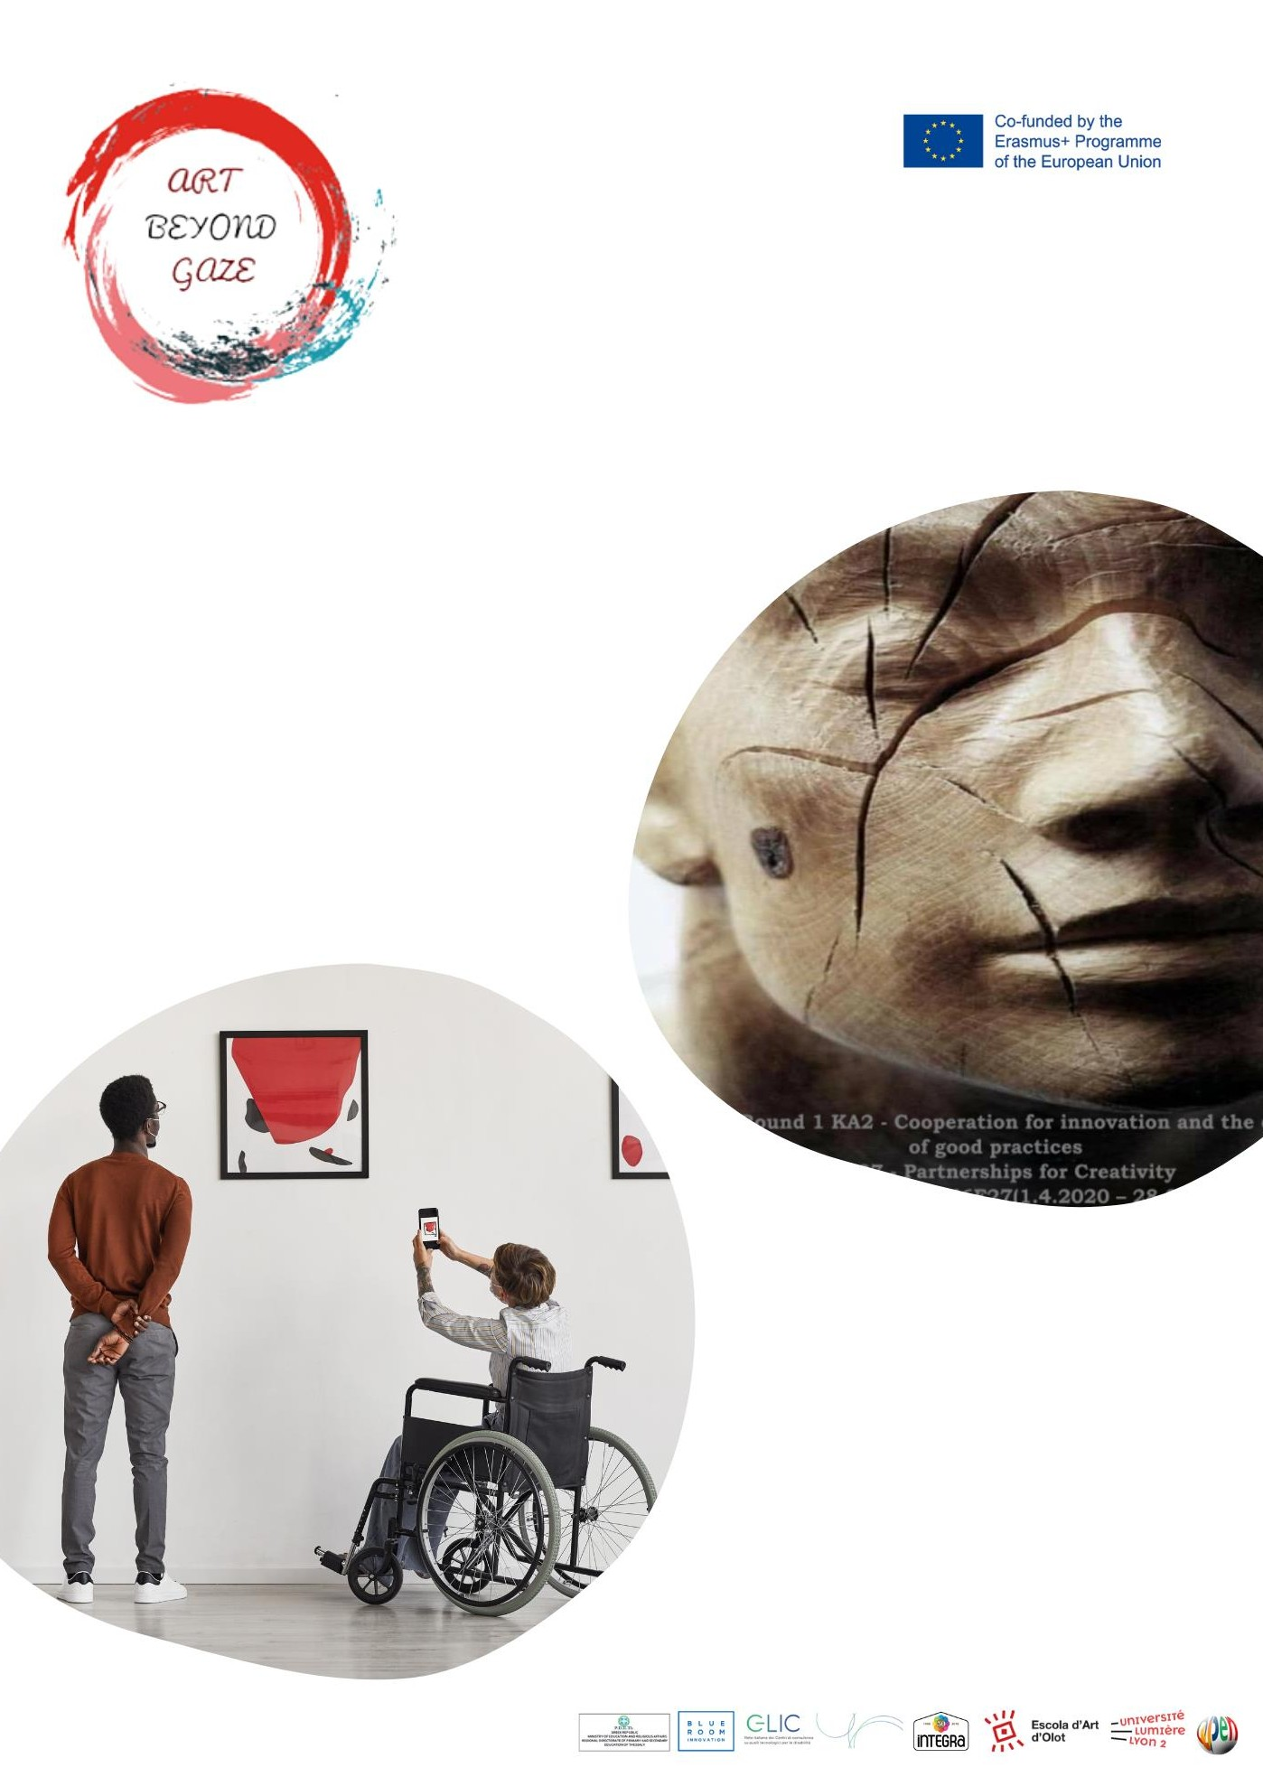

Final

Multiplier

Event

Olot

March 2023

COUNTRY | PARTNERS
SPAIN | 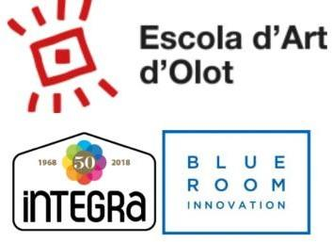

Introduction

The Spanish final event took place on March 27, 2023 in the magma room of the Space Crater, in Olot. The final event was attended by an amount of 21 professionals from the world of art, education and politics.

To begin the meeting, the results of the project were presented by Cristina Capel, from Escola Art Olot. Then, Estel Guillaumes from Blue Room Innovation explained the Project objectives and main results. After that Joan Morejon and Joana Vila, from Integra, explained the local workshop 1 “Digital game”, followed by Martí Pellicer, from Escola Art Olot, who explained C2 formation in Olot and workshop 2 “my space”; finally Estel Guillaumes present workshop 3 “evaluation videos” and the final conclusion and feedback space.

During this stakeholders event, all partners representatives which participated actively during this 3 years ABEYGA project, had the opportunity to share points of view, to give opinions about the results and make some evaluation about the project itself.

We were lucky to have also de cosellour of education who has experience on SEND students thus before her politic situation, she is very proud of being worked in Integra organization.

With both introductions, it was created into the room an atmosphere which engage the main stakeholders experts to share their concerns and experiences.

Feedback received

All participants were happy to be part of the finalization of the project thus in some way participated during this years and also know the difficulties and challenges carried.

Different representatives of the educational centers that had participated in some of the workshops, wanted to share the closure of the project with us. And show their appreciation for the experience offered.

On the other hand, the counselor of Education, Miss Mariona Camps, praised in her speech the work done and, especially, the collaboration established between the 3 different entities in the province of Girona. Because, how she said, it is in the collaboration between powerful entities that big projects happen. Finally encouraged the leaders of the project (Bluerrom, EAO and Integra) to ask for help from the city council to be able to promote and carry out more ideas and activities like those that had been carried out within the ABEYGA project.
Below we share some of the comments collected during the final event

MEETING RESULTS

Question/Statement | Common responses and opinions | Unique responses
What good practices have you implemented in your environment to encourage inclusive Art? | -Participation in the ABEYGA project video contest.  - No, apart from our participation in the workshop of the ABEYGA project, in my center we have not carried out any other specific activity on inclusive art. | -P9 inclusive dance show.  -I have used new digital tools to approach artistic creation to my students.  -We have promoted the collective and cooperative creation of a fresco on our school wall to celebrate the diversity of our society.
Do you think ABEYGA could be scaled up and implemented in schools and other educational settings? | -Yes, I would really like to see how inclusive art works in my classroom.  - Implementing a project like this in the Catalan education system would be a very important step in terms of inclusion of people at risk of social exclusion.
What improvements would you propose to increase and encourage schools to include Inclusive Art in their curriculum? | -Making educational leaders aware of the importance to do an emotional work.  -Approach art from a transversal work of all subjects and not only from visual and plastic education subject.
When practical and inclusive art practice is carried out, are all students interested? | -Yes because the interactions between different youngers it’s the best motivation ever!  -Most of them.  -Yes!! In fact I was very surprised by the motivation and involvement in which all my students responded. | - Just the ones who really love art.
How you think Abeyga results can be improved? | -Giving them some more time to implement projects and workshops.  -Improving the diffusion capacity.  -Be able to offer the experiences of the project through the curriculum.  -Have the support of the local government to implement the project in all schools in the province. | - It seems to me that they have been good results. No need to improve them!
Add lines as needed

Conclusions

In this Multiplier Event which took place in Olot the aims were to communicate the Project objectives and main results obtained, also to disseminate to the city, the main administration and the stakeholders, and it was the video contest award ceremony.

All the event's phases were very well received by the participants and the audience.

According to the attendant's feedback, we agreed that taking part in a European project gives the chance to all partners to generate future collaboration bonds.

This kind of project enhances the experiences in the artistic field, promoting tools that are accessible to all.

Invitation

Invitation was sent to all NEAC partners and also other interested contacts related to the project. To all of them was send the poster created with and explanatory email.

Furthermore poster was printed and shared in different schools, social media and public institutions.

Agenda

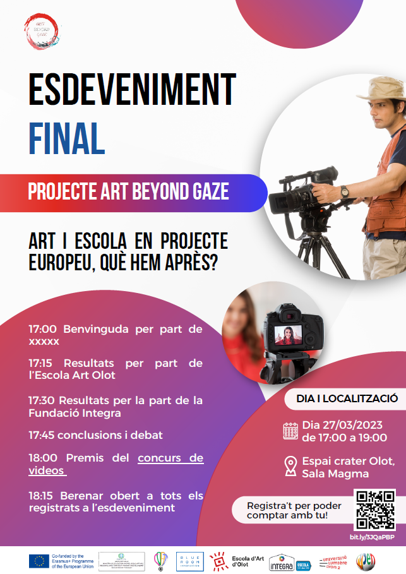

List of Participants

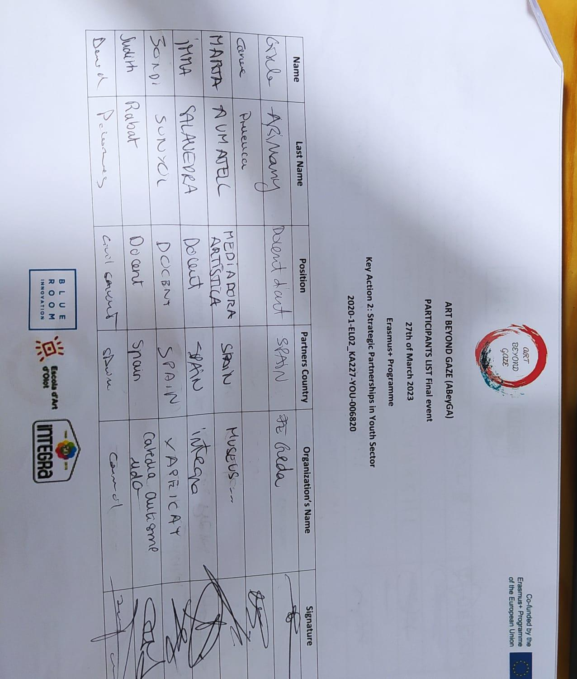
In the multiplier event, 20 participants attended, 4 of them from other countries.

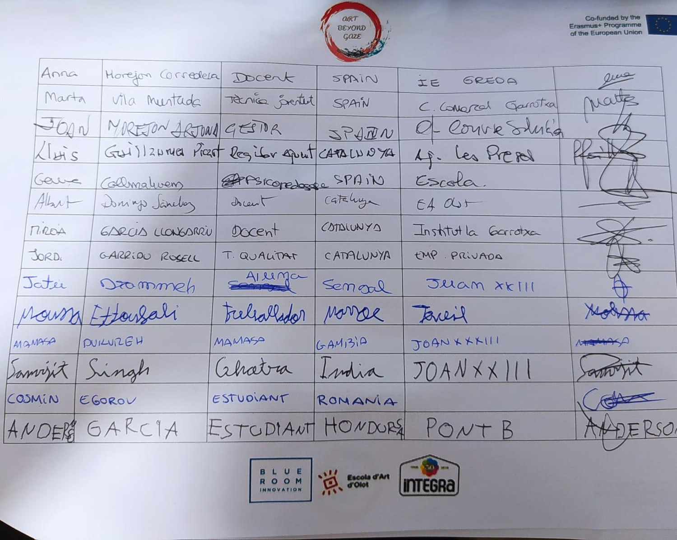

Photos

Room rented

Presentation of the meeting
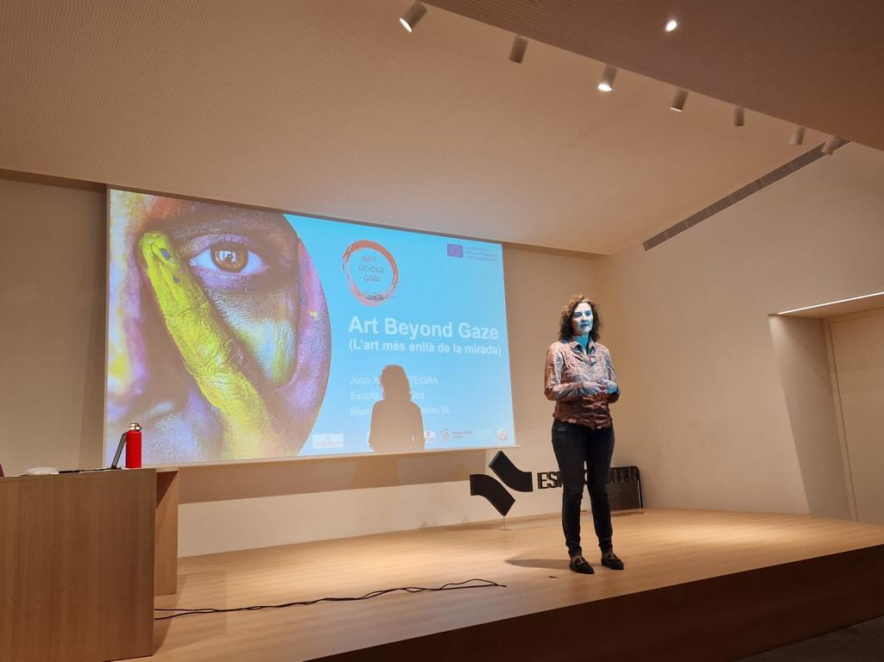

Explanation of the project results

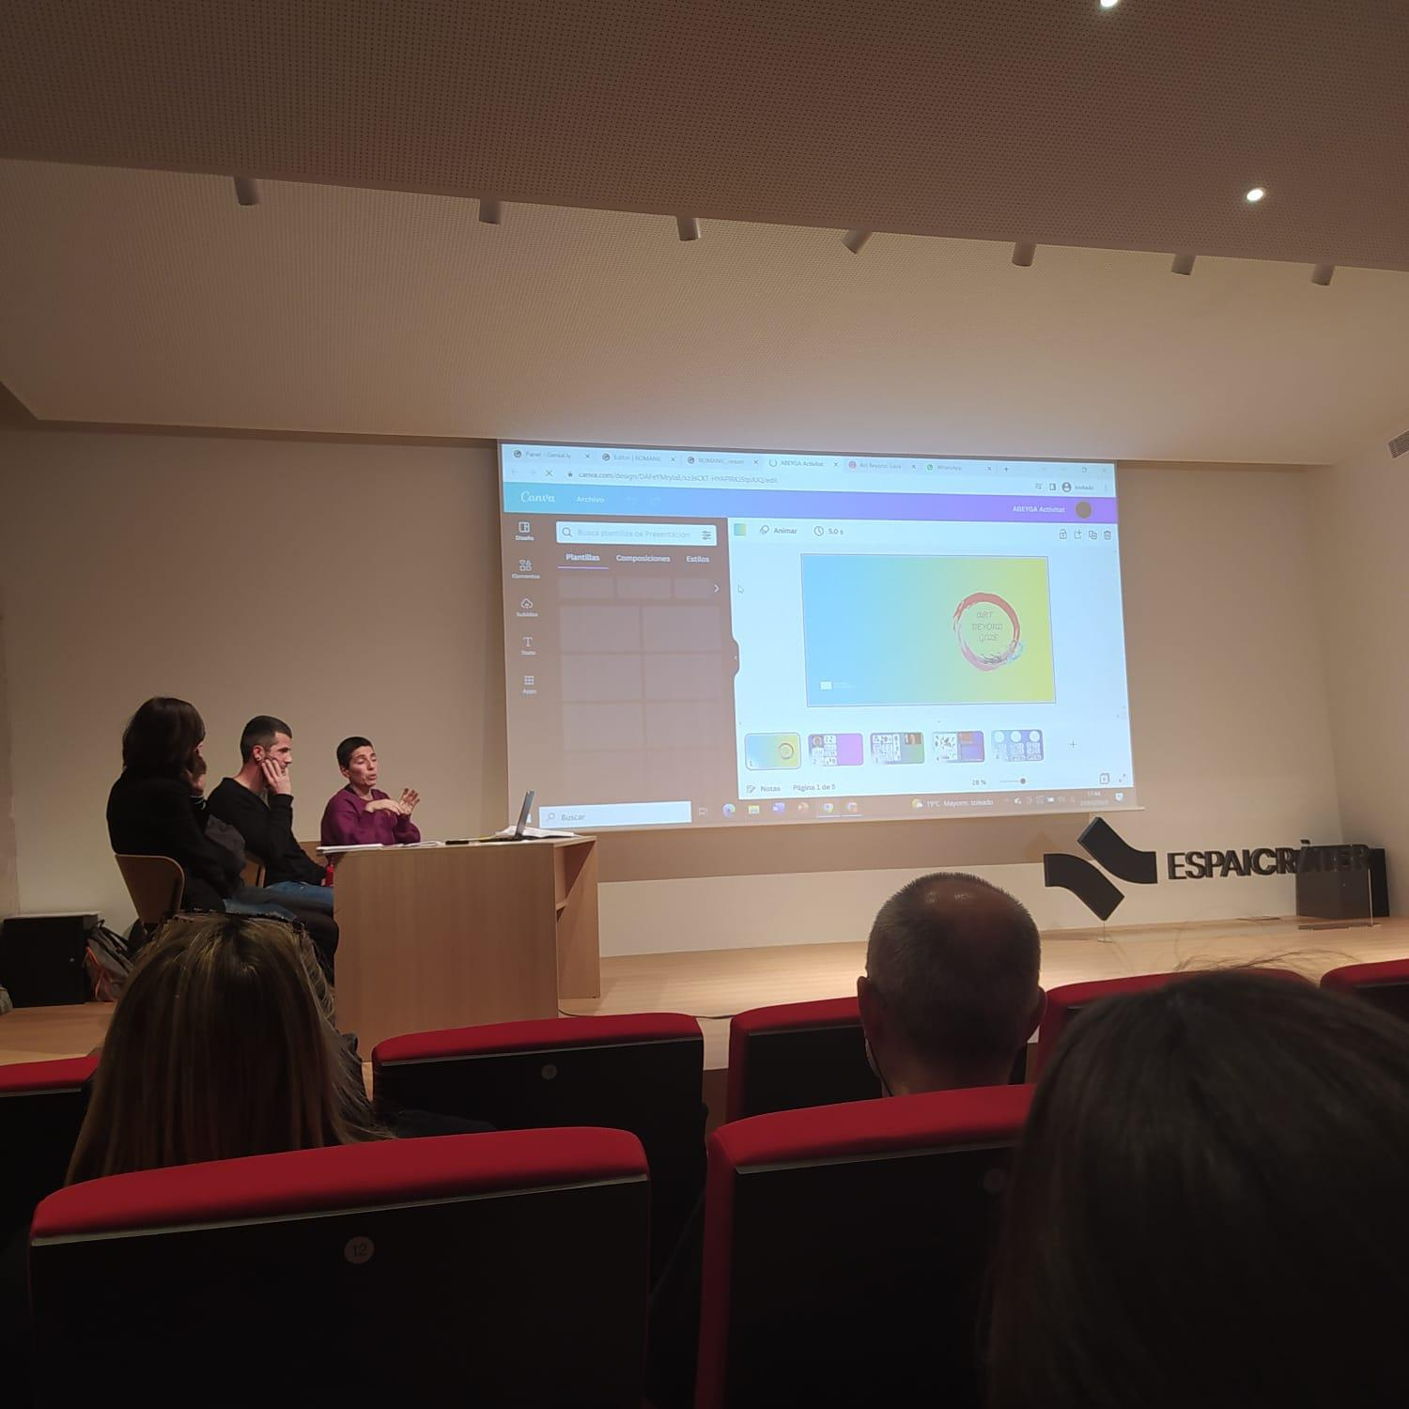

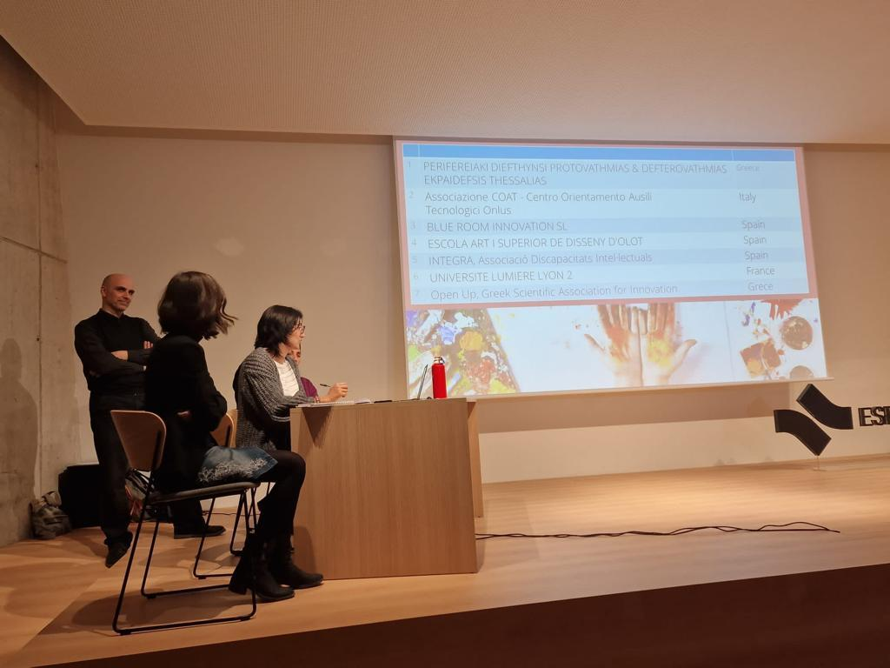

Finalization of the meeting

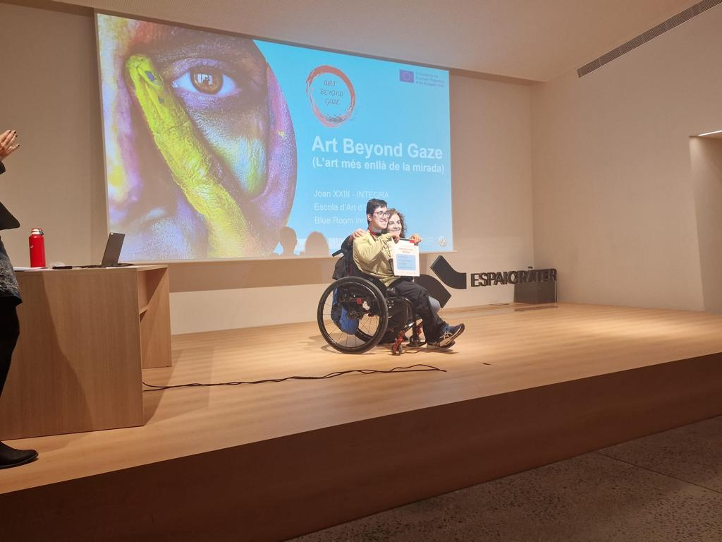

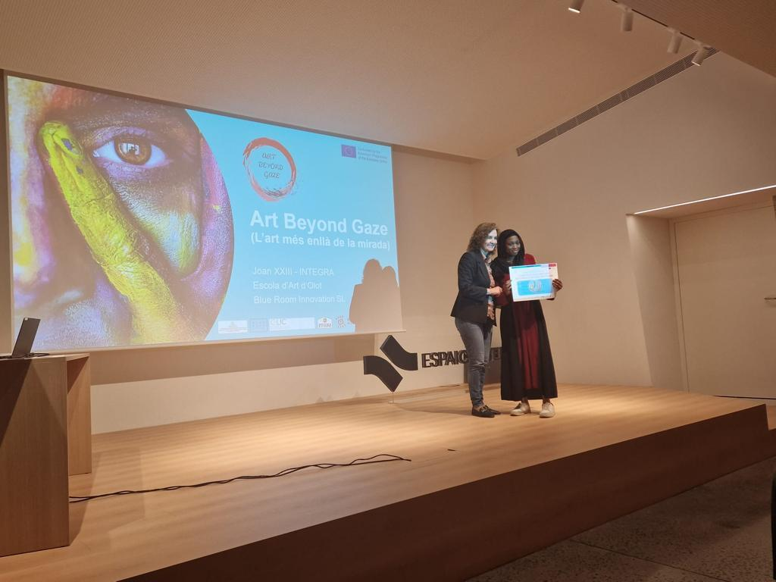

Coffee break for all participants

